|  |  |  |
| --- | --- | --- |
| **INFORMATION TECHNOLOGY** | **Course Code** | **ITC122** |
| **Description** | **Intro. to Web Design** |
| **NAME:** | **Project** | **Final** |

**Project:** E-Commerce website

An ecommerce website is your digital storefront on the internet. It facilitates the transaction between a buyer and seller. It is the virtual space where you showcase products, and online customers make selections. Your website acts as the product shelves, sales staff, and cash register of your online business channel.

**Instructions**:

* + Create and design an e-commerce website.
  + Website must have the following:

1. The mainpage, index or homepage must save as **main.html**
2. Name of your E-commerce website (e.g., store name, company, organization).
3. About the website (e.g., to inform the reader/client about the company and its operations)
4. Log in and Registration
5. Products, at least 10 minimum to be displayed including subcategories if any.
6. Product details (e.g., images, price, model, specification etc.…)
7. Upon selecting the item, indicate the add to cart and buy now button.
8. Any additional features will be graded as bonus points.
9. Database not required.
   * Upload to a free web hosting (e.g., GitHub) and shared the link to my messenger or to my email: jerie.bautista@arellano.edu.ph
   * Deadline of submission: May 1, 2024

**Guide for free web hosting using Github**

<https://pages.github.com/>

Visit Github Pages

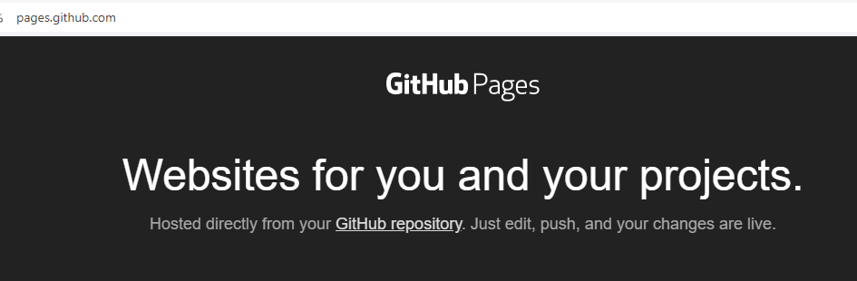

Sign up for Github if no existing account



Register your email

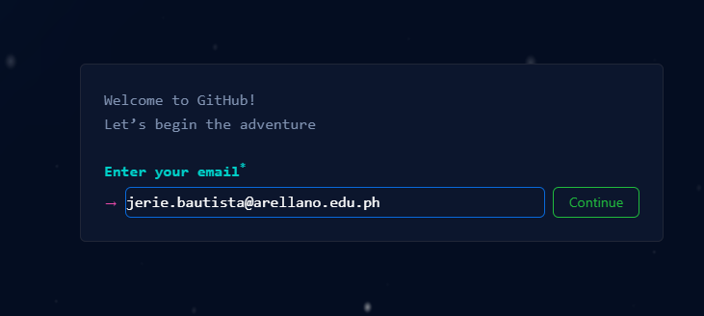

Create student account and continue for free

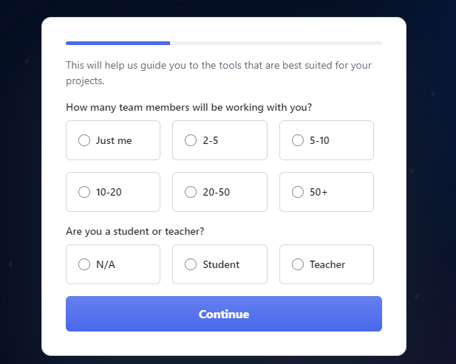

For more details open the link:

<https://drive.google.com/file/d/1ltKwH3eKIEh-tqr9o-bKQo8LdGRcCHXA/view?usp=sharing>

Note: If you used index file as your homepage then follow the process in the video renaming the main into index.